Unidata Community Equipment Awards Cover Sheet

Proposal Title: Development of the Caribbean Ocean Data Distribution and Visualization Laboratory
Date: March 10, 2009
Principal Investigator Name: Miguel Canals
Title: Assistant Professor
Institution: Department of Engineering Science and Materials, University of Puerto Rico at Mayagüez
Telephone number: (787) 832-4040 ext. 3065
FAX number: (787) 265-3816
Address: Stefani Building, Office 601, PO Box 9044, Mayagüez PR 00681-9044
Email address: mcanals@uprm.edu
Signature of PI: ______________________________________________________________

Name of Institution Official: Yuri Rojas
Title: Director, Research and Development Center, University of Puerto Rico at Mayagüez
Telephone number: (787) 831-2065
FAX number: (787) 831-2060
Email address: y_rojas@math.uprm.edu
Signature of University Official: _________________________________________________

Title: Development of the Caribbean Ocean Data Distribution and Visualization Laboratory
- Project Summary
The Principal Investigator proposes to develop the Caribbean Ocean Data Distribution and Visualization Laboratory (CODDViL) in support of the Caribbean Integrated Coastal Ocean Observing System (CarICOOS). This project will lead to the availability of real-time, near real-time and historical oceanographic and atmospheric data from the Caribbean region to the Unidata Community. CODDViL will publish data from the Caribbean region of waves, sea surface winds, coastal currents, baroclinic dynamics, sea level, salinity and temperature, among others.
The data distribution system will be comprised of a Thematic Real-time Environmental Distributed Data Services (THREDDS) Data Server (TDS) that will provide the Unidata Community with access to data from existing CarICOOS data streams, as well as to data from planned operational coastal circulation and nearshore wave models. A data visualization system will be developed to allow quick manipulation of large datasets using Unidata’s Integrated Data Viewer (IDV) and the NCAR Command Language (NCL).

- Project Description
The Caribbean Ocean Data Distribution and Visualization Laboratory (CODDViL), will be developed to allow standardized access to ocean and atmosphere data from the Caribbean region to the Unidata Community. CODDViL will be the official data distribution and visualization component of the NOAA-funded Caribbean Integrated Coastal Ocean Observing System (PI: Julio Morell, Co-PI’s: Jorge Corredor, Aurelio Mercado, Miguel Canals (PI of this proposal), Luis Aponte and Jorge Capella), which is in development at UPRM. The CarICOOS webpage is http://www.caricoos.org.
We will establish a THREDDS Data Server (TDS) as our primary data repository and web distribution vehicle. This task involves creating and standardizing an archival system that follows NOAA’s Data Management and Communications (DMAC) and Data Integration Framework (DIF) requirements. The necessary web applications (e.g. OpenDAP, OGC SOS) will be implemented to ensure that data delivery is compliant with NOAA’s DMAC/DIF standards. The main goals of the project include:
- To share oceanographic data from the Caribbean region with the Unidata Community, thus enhancing our region’s participation in the Unidata Internet Data Distribution (IDD) effort
- Increase awareness of Unidata data streams and data analysis software among students and faculty in the Caribbean region
- Upgrade existing hardware for oceanographic research and data analysis at UPRM
- Broadens the Unidata Community scope and capabilities by making available datasets from oceanography and ocean engineering disciplines, areas which are outside the traditional Unidata focus of atmospheric sciences
The present proposal is especially relevant to the two areas of special consideration for the 2009 Unidata Community Equipment Awards for the following reasons:
- UPRM is a minority institution with more than 99% Hispanic enrollment. The development of CODDViL at UPRM will enhance participation of underrepresented populations in the Unidata IDD effort
- There is a scarcity of real-time and near real-time data from the Caribbean region. CODDViL will provide useful datasets which are not currently available to the Unidata Community
- Equipment Details
Due to a drastic reduction in available funding for CarICOOS ocean observing efforts, no appropriate hardware is available to establish an operational THREDDS/OpenDAP server. The rapid increase in daily data production at CarICOOS has rendered existing hardware inadequate to deal with data distribution needs. The following equipment will need to be purchased to develop an operational ocean data distribution and visualization system for the Caribbean region:
THREDDS Data Server (TDS): The TDS will consist of an Athlon A64 2U Rackmount Server with 2 AMD Opteron 2350 2.00 GHz Quad-Core Processors, 8 GB 667 MHz DDR2 Ram and eight 1 TB 3.5 inch SATA 7200 RPM RAID drives.
Flow Visualization Workstations: Two powerful 64-bit LINUX workstations will be purchased to carry out demanding flow visualizations of very large datasets. IDV and NCL will be used for the preparation of graphical output. Multiple-gigabyte data files will be manipulated with these workstations.
The computing power of CODDViL will be used to develop novel user-responsive visualization schemes. Graphical output will include real-time and forecast plots of surface and baroclinic current fields, virtual Lagrangian particle trajectories and numerous animations.

- Contribution to Research:
CODDViL will support oceanographic research at UPRM and other regional and US institutions by providing standardized access to important datasets from the Caribbean region. Both students and faculty will have access to oceanographic data for coursework and research purposes. Three current M.Sc. students in physical oceanography at UPRM will conduct visualizations related to their thesis research with the CODDViL computing equipment.
The PI, a new faculty member at UPRM (started January 2009), is developing the Coastal and Environmental Fluid Dynamics Laboratory (CEFDL), the only one of its kind in the Caribbean Region. It is expected that large experimental and numerical datasets will result from the research at CEFDL, and these will be analyzed using CODDViL hardware. The output of very high resolution Boussinesq wave models will also be analyzed with the flow visualization workstations, using IDV, NCL and other software.

- Contribution to Education:
The University of Puerto Rico at Mayagüez boasts the largest number of Hispanic engineering students in the US. Some of these students go on to graduate studies in oceanography or atmospheric sciences. The PI teaches undergraduate fluid mechanics to civil engineering, mechanical engineering and physics students at UPRM. Flow visualizations play a large role in the visual learning of fluid mechanical concepts. IDV makes the visualization of streamlines, isosurfaces and vectors easy and user-friendly, and these are fundamental concepts in fluid mechanics education. The PI will use IDV graphical output (e.g. streamline, vector field and isosurface plots) as part of the PI’s initiative to expand the use of flow visualization in the classroom. This will expose undergraduate students in mechanical and civil engineering to Unidata’s flow visualization software. The purchased equipment will also be used in the teaching of coastal engineering courses as part of the PI’s planned minor program in Coastal Engineering within the College of Engineering at UPRM. CODDViL hardware can also be used in oceanography courses taught at the Department of Marine Sciences at UPRM such as Geophysical Fluid Dynamics and Physical Oceanography.
CarICOOS investigators regularly conduct seminars and workshops, aimed at CarICOOS users and stakeholders, on how to utilize the data streams available for ocean observing at the CarICOOS website. We will use these opportunities to promote the use of IDV and data streams available to the Unidata Community among workshop attendees.
The development of CODDViL will be vital in accomplishing CarICOOS’ mission which is supported by UPRM: to develop the necessary data products for ocean observing as well as increase local expertise via student and faculty training. This will allow Caribbean residents to adequately respond to needs related to the interaction between their community and the coastal environment.

- Contribution to UNIDATA Community
Real-time, near real-time and historical data will be made available to the Unidata community through the proposed project. The following in-situ real-time or near real-time data will be available via CODDViL to the UNIDATA Community:
- CODAR surface currents
- Meteorological products from hurricane-hardened weather stations
- Temperature, salinity, waves and currents from oceanographic buoys
- Weather balloon profiles (from NWS-San Juan)
The following numerical models are being developed in-house for the Caribbean region by the CarICOOS modeling component:
- ADCIRC: coastal currents
- WW3 / SWAN: coastal waves
- BOUSS2D / STWAVE / COULWAVE: phase-resolving wave modeling (not real-time)
- WRF 3.0: wind products
- Regional Ocean Modeling System (ROMS): baroclinic currents
An experimental nowcast/forecast implementation of NCAR’s WRF 3.0 was developed locally and is already available online at http://www.caricoos.org. Graphical output is produced using NCL, as shown in figure 1. In addition, data from models that will be obtained via online portals and OpenDAP servers include:
- NOAA’s Real-Time Ocean Forecast System (RTOFS)
- GFS wind products
- Hybrid Coordinate Ocean Model (HYCOM)

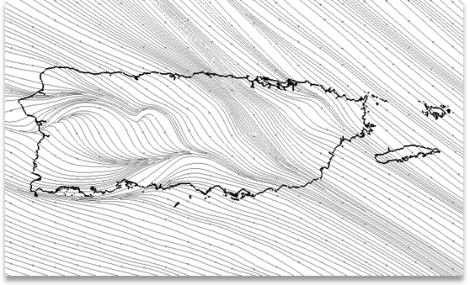
Figure 1. Surface streamlines from experimental WRF 3.0 model for Puerto Rico.
The following regional remote sensing products will also be distributed via CODDViL:
- Surface chlorophyll composite imagery
- Suspended sediment products for water quality
- QuikSCAT winds at 12.5 km resolution
- Synoptic imagery and trend analysis for sea surface temperature
In accordance with DIF standards, all gridded model data will be encoded in NetCDF and distributed via OpenDAP, while in situ data will use the OGC SOS web service in XML format. Remote sensing imagery will be distributed via OpenDAP as GeoTIFF, PNG, etc. A schematic of the data streams and distribution formats is shown in Figure 2.

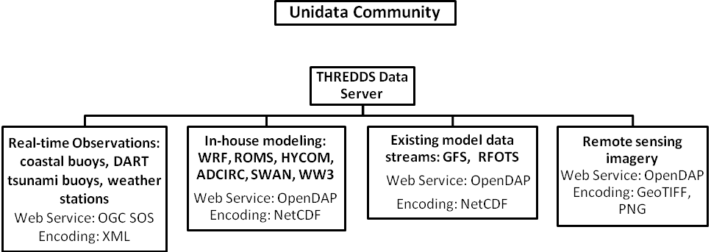
Figure 2. Data streams to be made available to the Unidata Community via CODDViL – CarICOOS.

- CODDViL and available computing resources
The hardware to be purchased will be installed in the Physical Oceanography Laboratory at UPRM, which houses the computing resources of CarICOOS. The existing computing facilities are comprised of:
- 2 rack-mounted servers, each with 32 processors (8 AMD quad core processors) and 32 GB of RAM. Most of the ocean modeling is carried out with these servers.
- A Western Scientific workstation with 2 AMD dual core processors and 16 GB RAM. The WRF 3.0 model is run daily on this computer.
- Several PC’s for graduate students and visitors, for basic data analysis and word processing, etc.
The TDS will be mounted on the rack with the 2 servers allocated for high performance computing. All servers will use the same APC Smart-UPS for power supply. The total cost of the existing hardware is about $65,000. The total value of the proposed equipment is about $20,000, which comprises about 31% of the existing computing resources.
- System Management
The data distribution system will be developed by CarICOOS’ IT personnel, Damian Irizarry and Christian Sueiras, both of which come from UPRM’s computer engineering talent pool. CarICOOS modeling director Jorge Capella, the PI and several CarICOOS-funded graduate students in physical oceanography are in charge of model development and validation. The PI will lead the visualization component to ensure graphical output maximizes information display and utilizes the full capabilities of IDV and NCL. All PI and staff time will be covered by the CarICOOS project.

- Budget
A drastic reduction in CarICOOS funding for FY 2010-11 has resulted in limited resources available for the acquisition of the necessary hardware to ensure DMAC-DIF compliance. The following table provides a list of the equipment to be purchased.
Item | Quantity | Unit Cost | Total
THREDDS Data Server:  2 AMD Opteron 2350 2.00 GHz Quad-Core Processors  8 GB DDR2 Ram  8 TB Hard Drive (8 x 1 TB) | 1 | $4,200 | $4,200
Flow Visualization Workstation:  2 AMD Opteron Quad-Core 2358 SE 2.4 Ghz Processors  32 GB DDR2 RAM  1 TB Hard Drive | 2 | $7,300 | $14,600
22 inch monitor | 2 | $ 250 | $ 500
shipping | 1 | $340 | $340
Total |  |  | $19,640

As mentioned in the previous section, all PI and staff time related to CODDViL system development, management and maintenance will be covered by the NOAA-funded CarICOOS project.

D. Project Milestones
The following table lists relevant project milestones and the expected time (after award date) for task completion. CODDViL and CarICOOS will evolve in unison, and we expect that by Fall 2010 a truly operational ocean observing system will publish all ocean-observing data from the Caribbean to the Unidata Community.
 | Time in months from award date
Task | 2 | 4 | 6 | 8 | 10 | 12 | 14 | 16 | Long term
Purchase hardware
Develop THREDDS Server
Production of graphical output
Deploy Operational TDS System
Operational CarICOOS System

Appendix: BIOGRAPHICAL SKETCH – Miguel Canals
3/16/2009

Address: Department of Engineering Science and Materials
University of Puerto Rico a Mayagüez
PO Box 9044, Mayagüez, PR, 00681
Phone: (787) 832-4040 ext. 3065
Fax: (787) 265-3816
E-mail: mcanals@uprm.edu
Website: fluids.uprm.edu/mcanals.html
Born: October 21, 1981; San Juan, PR

Education
2003 B.Sc. in Biology, University of Puerto Rico at Mayagüez
2005 M.Sc. in Oceanography, University of Puerto Rico at Mayagüez
2008 Ph.D. in Ocean Engineering, University of Hawaii at Manoa

Professional History
2009 – Present: Director, Fluid Mechanics Laboratory, Department of Engineering Science and Materials, University of Puerto Rico at Mayagüez
2009 – Present: Assistant Professor, Department of Engineering Science and Materials, University of
Puerto Rico at Mayagüez
2005 – 2008: Graduate Research Assistant, University of Hawaii at Manoa
2003 – 2005: Graduate Research Assistant, University of Puerto Rico at Mayagüez

Awards
American Physical Society Gallery of Fluid Motion Award (2007)

Professional Societies
American Geophysical Union
Marine Technology Society
American Physical Society Division of Fluid Dynamics

Research Interests
Vortex dynamics, stratified flows, coastal hydrodynamics and sediment transport. Fundamental, geophysical and environmental fluid dynamics, numerical and experimental flow visualization.

Journal Publications
Canals, M. and G. Pawlak, "Three-dimensional vortex dynamics in oscillatory flow separation", in preparation for submission to Journal of Fluid Mechanics, 2009.
Canals, M. and G. Pawlak, "Topology and breakdown of Görtler vortices on an oscillating cylinder", Physics of Fluids, Gallery of Fluid Motion, Vol. 20, no. 9, pp 091102, 2008.
Canals, M., G. Pawlak and P. MacCready, "Tilted baroclinic tidal vortices", Journal of Physical Oceanography, Vol. 39, No. 2, pp. 333-350, 2008.

Scientific Collaborators
Julio Morell, Jorge Capella and Jorge Corredor; University of Puerto Rico at Mayagüez

